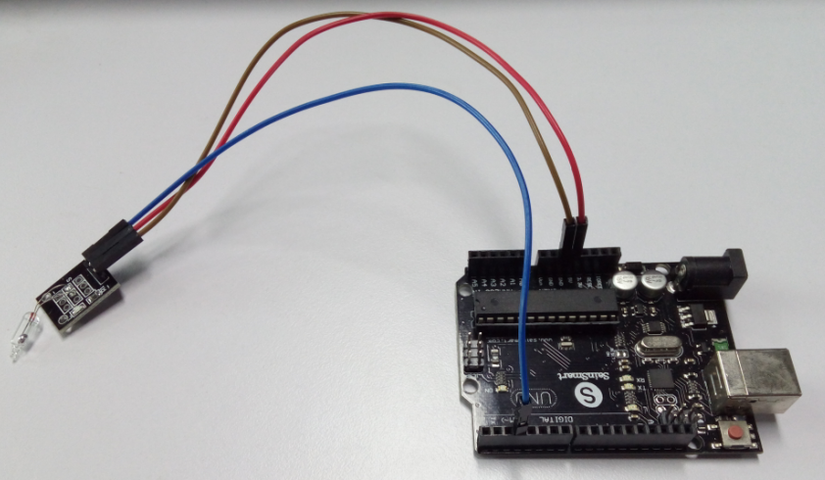

int Led=13;

int buttonpin=3;

int val;

void setup()

{

pinMode(Led,OUTPUT);

pinMode(buttonpin,INPUT);

}

void loop()

{

val=digitalRead(buttonpin);

if(val==HIGH)

{

digitalWrite(Led,HIGH);

}

else

{

digitalWrite(Led,LOW);

}

}